ACRONYM
  - Proposal full title
Project coordinator (Organisation - Country)

Maximum limit: 8 pages in total
Text in green is for guidance purposes and is to be deleted from the final document.

General Guidance
The Call Text and its annexes can be downloaded from the RAMP website.
- All pre-proposals must be submitted via the ESES – Electronic Submission and Evaluation System. Some information is to be entered directly in the platform and some is to be uploaded as PDF files:
  - Information such as the consortium composition and partner details (including contacts, start and target TRLs, efforts in persons.month, budget and funding details) will be collected via the submission platform.
  - Applicants will need to complete an ethics self-assessment in the ESES. For more information on each of the ethics issues and how to address them, including detailed legal references, please consult the Horizon Europe Programme Guidelines
  - Proposal keywords and public abstract will be collected via the submission platform
    - The abstract must clearly describe the proposal and its main objectives, it must not contain confidential information and it should be accessible to a technical but broad audience. This abstract may be used for communication and dissemination activities should your project be selected for funding. Please make sure that it is publishable.
  - CVs of the principal investigators of the consortium (1 page each) will be uploaded as PDF.
  - The technical description of the proposal (this template) will be uploaded as a PDF.
The platform will compile all the provided information into one single PDF, which will be the pre-proposal to be submitted to RAMP.
- All partners of the consortium (including self-funded partners) must log in on the ESES, complete the required information and confirm their participation
  - It is strongly recommended that the partners familiarize themselves with the platform and that the submission is done before the final days of the call, as RAMP will not accept late submissions and will not extend the submission deadline for technical issues which are not under its direct responsibility.
    - The submission can be saved for later completion or corrections, up until the submission deadline.
    - Only the last submitted version of the pre-proposal will be considered by the Joint Call Secretariat.
  - It is not possible to edit or submit a pre-proposal after the submission deadline.
- The content of the pre-proposal must be written in English and follow the RAMP guidelines. Proposals which are incomplete, do not adhere to the general guidelines or that do not comply with the general and the funder-specific eligibility requirements will be considered ineligible and, therefore, will not be evaluated.
- Any documents other than those requested as part of the proposal will not be forwarded to the Call Evaluation Panel.

Rules and guidelines for the “technical description” PDF
- The file containing the technical description of the pre-proposal must not exceed 8 pages. All tables, figures, references, and any other element pertaining to this section must be included as an integral part of these sections and are thus counted against this page limit.
- Proposals are to be evaluated solely based on the information contained within the maximum page limits (technical description and CVs): links and hyperlinks to additional documents or external sources of information are not allowed.
- The formatting conditions of the template are in place to ensure the fairness and equity of the process and are not to be modified. Any modifications aiming at circumventing the maximum page limit (such as text font and size, margins, spaces between lines and paragraphs) may result in the ineligibility of the proposal.
  - The following formatting conditions apply:
    - The reference font for the body text of proposals are Georgia or Arial (regular). The minimum font size allowed is 11 points. Standard character spacing and a minimum of single line spacing is to be used.
    - Text elements other than the body text, such as headers, foot/end notes, captions, formulas and references, may deviate, but must be legible.
    - Text in figures and tables may deviate, but must remain easily readable. Any information which is not easily readable may be disregarded in the evaluation of the proposal, which may impact its final score.
    - The page size is A4, and all margins (top, bottom, left, right) should be at least 1.27 cm (not including any footers or headers).
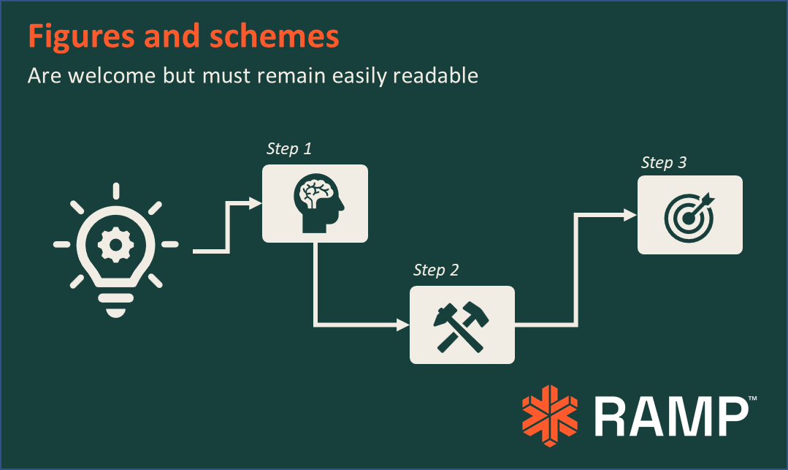
      - All elements in the proposal, including figures and tables, must be within the margins.
Figure 1 - Sample figure. Information must remain easily readable and figures should not go over the page margins.

Table 1 - Sample table. All information must remain easily readable and tables should not go over the page margins.
Sample table | A | B | C
1 | Font type and size may vary from the main body of the text but must remain legible. | - | -
2 | - | Any information which is not easily readable may be disregarded in the evaluation of the proposal, and the resulting scores may be reduced accordingly. | -
3 | - | - | Tables or other elements that extend over the original dimensions of the margins of the template will be considered as a way of attempting to circumvent the maximum page limit. This may lead to the ineligibility of the proposal, to safeguard the fairness of the evaluation for all applicants.

Checklist for submission
In order to make sure that your proposal will be eligible for this call, please collect the information required in all the sections below before starting the submission process.
- The proposal complies with all transnational eligibility requirements as stated in the section 7.1.1 of the call text.
- All partners requesting funding have ensured they fulfil the national/regional requirements of their respective funders as stated in the Annex 1 of the call text, including notably the need for additional national/regional procedures/documents.
- All partners who do not request funding are able to provide financial resources for their own contribution. Partners for which funding rates are not 100% are able to provide financial resources for the share of their costs which is not eligible within RAMP.
- All partners are aware of the funding and monitoring requirements that apply to funded projects, both at transnational (sections 10 and 11 of the call text), and national/regional levels (according to each funder’s rules).
- The information entered in the ESES is identical to the information included in the “technical description” PDF. In case of inconsistency, the information entered in the ESES shall prevail.
- The structure and formatting of the mandatory template for the “technical description” PDF have not been modified.

Pre-Proposal technical description

The pre-proposal technical description is divided into 3 main sections, which are mandatory. The subheadings are not mandatory but recommended since they align with the stage 1 evaluation criteria. It is allowed to include additional subheadings.

Excellence

Objectives

Clearly state the objectives of the work to be carried out, highlighting the pertinence of these objectives relative to RAMP and its Strategic Research and Innovation Agenda, and to the selected call topic and its expected impacts.

Positioning of the proposed work relative to the state of the art

Clearly position the proposal regarding the current state of the art and the expected progress beyond it. State its ambition, originality, innovation/economic potential, and ground-breaking objectives.

Added value of transnational cooperation

Highlight the experience, balance and complementarity of expertise of the consortium. Demonstrate the relevance of the cooperation in the consortium for each of the funders involved and to the planned work. Provide enough information to substantiate the correspondence between the expertise and the role of the partners within the consortium.

Concept and approach

Briefly describe the overall methodology, including the underlying concepts, models, assumptions and interdisciplinary approaches that underpin your work. Briefly explain how this will enable your project to deliver its objectives and the feasibility of the project within the planned timeframe. If applicable, indicate start and target TRL.

Impact
Under this criterion, where possible and meaningful, provide quantified estimates, and explain your baselines, benchmarks and assumptions used for those estimates.

Expected outcomes and impacts

Briefly explain how the project’s results are expected to make a difference in terms of impact, beyond the immediate scope and duration of the project, at regional, national and/or international level, according to the expected impacts for RAMP and the specific call topic.
Briefly describe the foreseen activities on exploitation, dissemination and communication of project results to different target audiences including the wider society.
Impacts may include: enhancing innovation capacity; creating new market opportunities; strengthening competitiveness and growth of companies; bringing societal benefits; addressing barriers/obstacles in framework conditions such as regulation, standards, public acceptance, workforce considerations, financing of follow-up steps, cooperation of other links in the value chain.

Cross-cutting aspects

Explain how the proposal integrates aspects such as: gender and diversity perspectives; engagement of stakeholders; environmental, ethical, political, social and/or cultural dimensions. If such aspects are considered not relevant for the proposal in question, please justify.

Implementation
Detailed task descriptions, risk assessment, data management issues, regulatory and ethics issues can be described in the full proposal at Stage 2.

General description of the workplan and the role of each partner in the proposal

Provide enough information to demonstrate that the activities of each partner are relevant within the proposal and compatible with the applicable rules of the respective funders. This includes a broad description of the work packages and timing, as well as the overall management of the project

Qualitative description of the costs

Provide enough information to demonstrate that the total costs are compatible with the scale and ambition of the proposal; and the funding requested by each partner is overall in accordance with the requirements of the respective funders.
It is advised to explain or highlight aspects that may not be immediately evident to experts from countries other than those included in the consortium (for example: apparent disparities in costs due to economic differences between countries or different cost eligibility rules).

Information on costs and requested funding will be collected directly via the ESES, divided in the following categories: personnel, travel, consumables/equipment/subcontracts and other. Please note that this division cannot be changed, and that it may differ from the categories applied by your organisation.
The total costs and efforts in persons.month are to be indicated considering the entirety of the resources that will be employed in the proposal. The requested funding is the share of the total costs which is eligible for funding according to the specific funder’s rules. The ‘own contribution’ is the share of the costs which is not covered by the requested funding.

